Drawer with Navigation of pages

Exercise #2

Flutter Developer Bootcamp

# **Purpose**

This exercise demonstrates basic navigation implementation in a Flutter application using routes and a drawer menu.

**Problem**

In the provided Exercise You need to create as follows:

In the given exercise Create a Flutter application with basic navigation features. It defines three routes: home, profile, and settings. Each route corresponds to a specific page: the home page with a drawer menu, the profile page, and the settings page. Users can navigate between these pages using the drawer menu or directly accessing the routes.

**How to Solve**

1. Checkout the exercise from Git Repo:

git clone -b <user-branch> <repo-URL>

2. Open the root folder inside VS Code

3. To build the app click the run option in the main method{}

4. Imports the Flutter Material package and defines the main function.

5. MyApp class configures the MaterialApp widget, setting the app's title, theme, and routes.

6. MyHomePage, ProfilePage, and SettingsPage classes represent different screens of the app.

7. Each screen includes an app bar with a title and a drawer menu with options to navigate between screens.

8. ListTile widgets inside the drawer handle navigation using onTap callback functions.

9. Go To File: <specific-file-with-navigation-method> à <method-name>, implement your logic.

**You will Achieve**

When you complete this Exercise you will learn the following:

**Widgets Included:**

* **MaterialApp:** Provides the root widget for the application, defining its title, theme, and routes.
* **Scaffold:** Defines the basic structure of each screen, including an app bar and body content.
* **AppBar:** Displays a header with a title for each screen.
* **Drawer:** Implements a side navigation menu for easy access to different screens.
* **ListView:** Displays a scrollable list of items inside the drawer.
* **DrawerHeader:** Represents a header section within the drawer menu.
* **ListTile:** Represents individual items in the drawer menu, each containing an icon and text.
* **Navigator:** Facilitates navigation between screens when tapping on items in the drawer menu.

# **Screenshots**

## **Expected output(with drawer and navigation of pages)**

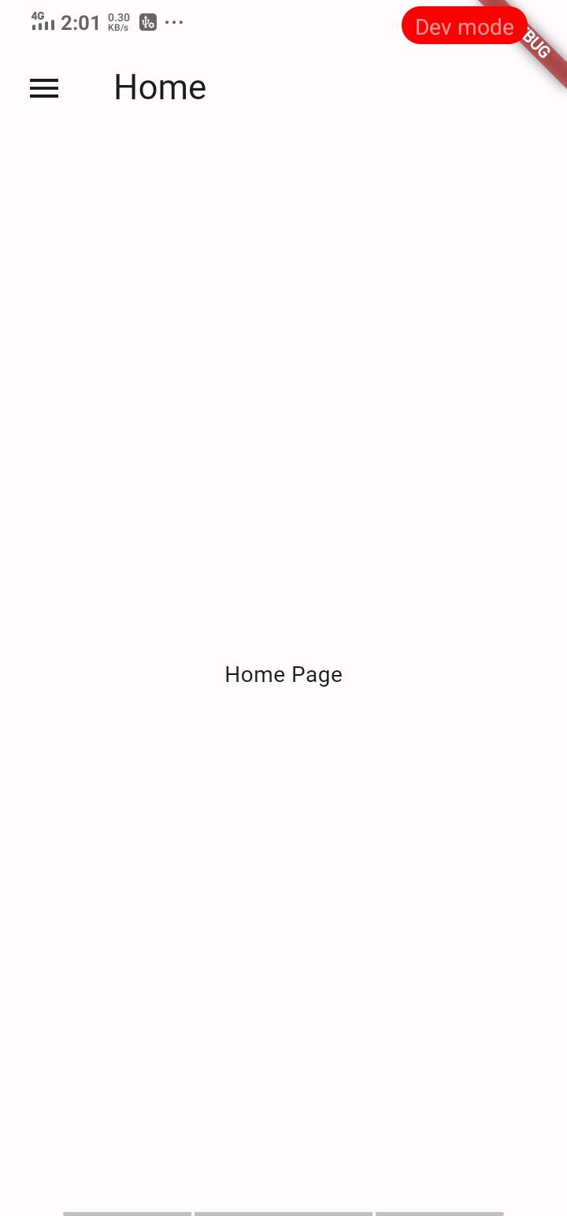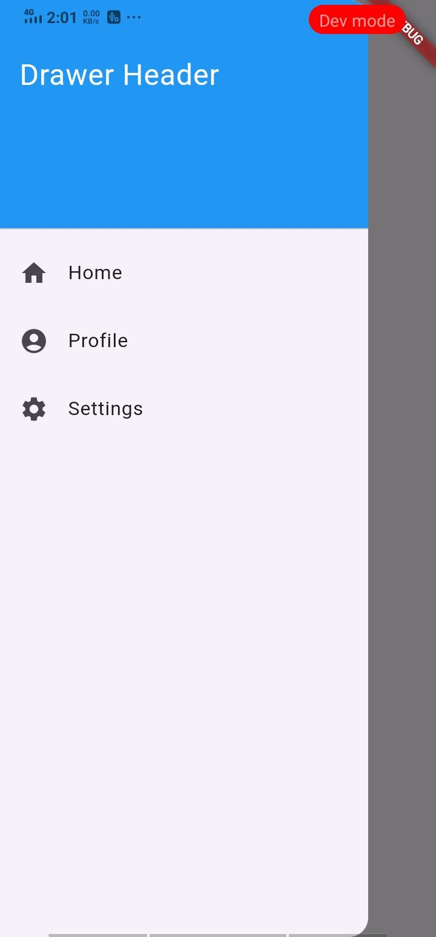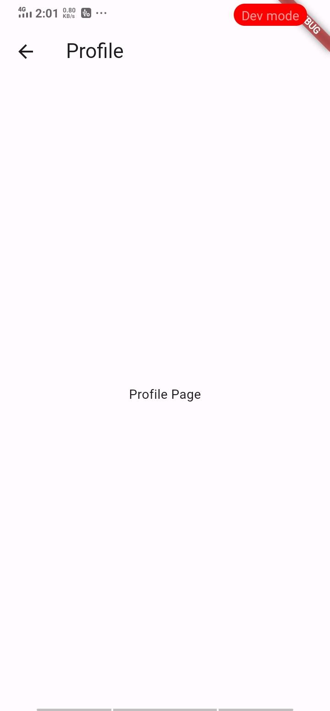

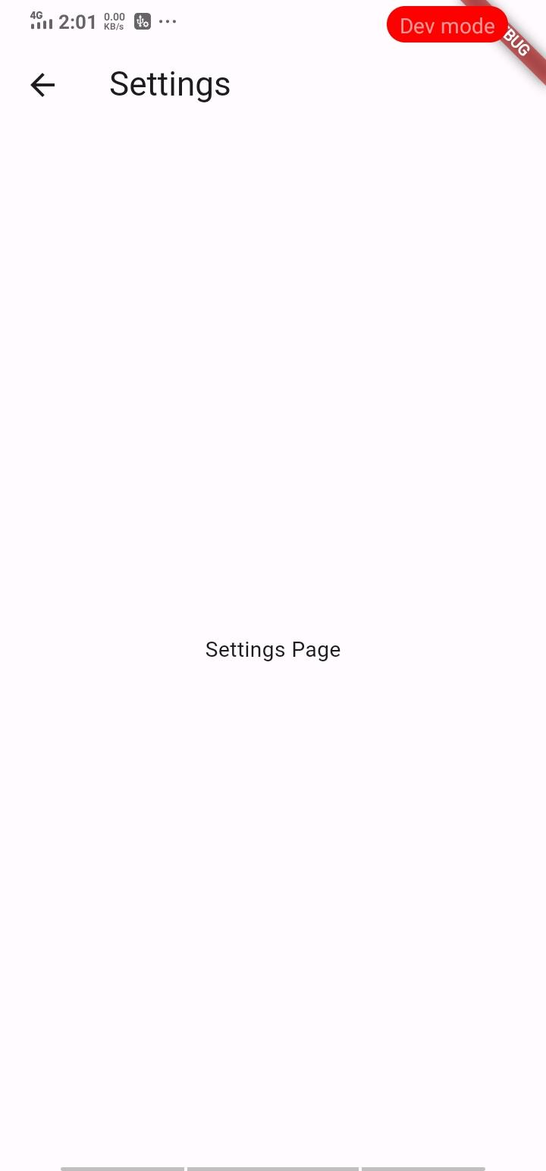

# **How to submit your Exercise**

Push your project back to the same git branch using command:

<command name>

# **Happy Coding!**